**LITERATURE SURVEY ON A GESTURE-BASED TOOL FOR STERILE BROWSING OF RADIOLOGY IMAGES**

**ABSTRACT:**

As doctors interact with computers in the operating room (OR), new modalities are required that facilitate medical image manipulation while maintaining sterility, allowing them to pay attention to what they are doing, and allowing them to react as quickly as possible. An electronic medical record database can be navigated and manipulated with the help of a vision-based hand gesture capture and recognition system called Gestix. A system that captures video is used to translate navigation and gestures in to commands based on their temporal trajectories. The brain biopsy procedure involved the use of "Gestix.". This interface enabled rapid intuitive reaction and easy interaction by the surgeon while preventing focus shift and change of location. Based on the results of two usability tests, the nonverbal conversational modalities of human-computer interaction are discussed as well as implications for human-computer interaction.

**INTRODUCTION:**

Hospitals are increasingly adopting computer information technology. In this process, doctors must be able to interact efficiently, intuitively, accurately, and safely without affecting the quality of their work. Human-computer interaction is primarily conducted through keyboards and pointing devices. ICUs are notorious for spreading infections through the use of computer keyboards and mice by doctors and nurses. A major advantage of hand gestures over existing interface techniques is their sterility, as outlined in the paper. Voice control provides sterility as well, but its high volume makes it problematic.

Gestures are non-verbal communication made with the hands that we refer to in this work as a basic form of non-verbal communication. Early childhood gestures are used by children to communicate before they learn to speak, according to psychological studies. When people talk to each other about an object, manipulation is often used as a form of gesticulation. More natural interfaces (e.g., keyboard, mouse, joystick) have natural expression, unencumbered interaction, intuitiveness, and high sterility.

With the aid of a graphical user interface, we present a video-based system for capturing and recognizing hand gestures for manipulating magnetic resonance images (MRIs). An appropriate vocabulary of hand gestures of commands was chosen because each gesture corresponds cognitively to the concept or command it is meant to represent. Leaving the hand in the left direction is equivalent to turning left.

In order to assess the functionality of the gesture interface, it was tested at the Washington Hospital Center in Washington, DC. A hand gesture system was tested in the hospital's neurosurgery department after two procedures were observed and insights were obtained. The use of an in vivo gesture recognition tool in a neurosurgical biopsy is the first time we've seen it successfully implemented. In order to avoid contamination of the patient, the OR, and the surgeon, a sterile human-machine interface is imperative.

**PROBLEM STATEMENT:**

In earlier days it is difficult to take an X-ray or scan ,so that people have to move where it is available, and also operating the machine is also hard ,as the technology have developed it changed to take scans easily at the hospital, but the accuracy have not been developed. So to overcome those problems we have produced a model which can operate through GESTURES .So that we can predict easily where the disease is , and can also scan deeply so that machines can be operated easily and images can be identified easily.

**GESTURE IDENTIFICATION:**

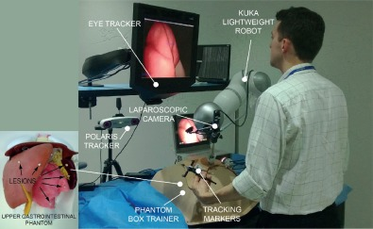

The gesture is identified easily as shown in the above picture, and through that we can predict which part is affected ,also we can sense the damage in neurons.

**RADIOLOGY IMAGES:**

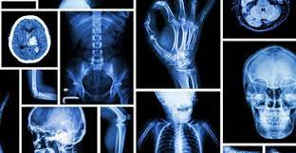

The radiology images is shown above, if we want to deeply sense disease in our body then we can use our GESTIX.

**CONCLUSION:**

A vision-based capture and recognition technology is used to interpret the user's gestures to navigate and manipulate images in an electronic medical record (EMR) database.